October 20, 2017

Task 1 – Main App screen

 | CS2001 - Group Project| 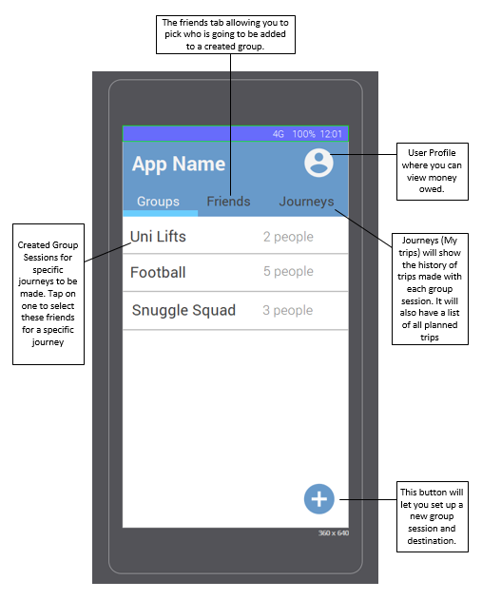

The main screen of the app that will allow people to set up new sessions for a journey and access journey history. There will be a login screen required before reaching this screen. This screen is going have a list of all friends the user has added and will show who is in the driver role and who is in the rider role.

|  |  |
| --- | --- |
| STUDENT NAME: | **Ravjeet** |
| STUDENT NAME: | **Chris** |

|  |  |  |  |
| --- | --- | --- | --- |
| Comments | Date | Done | Group member |
|  | [Date] | ☐ |  |
|  | [Date] | ☐ |  |
|  | [Date] | ☐ |  |
|  | [Date] | ☐ |  |

Login Screen (Wireframe)

This is the wireframe design for the login screen which will be the first screen users see when they start the app. From here the user can go and create an account or login to the app with an existing account.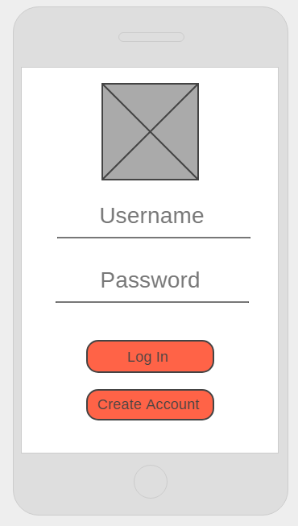

|  |  |
| --- | --- |
| STUDENT NAME: | **Ravjeet** |
| STUDENT NAME: | **Chris** |

|  |  |  |  |
| --- | --- | --- | --- |
| Comments | Date | Done | Group member |
| This screen should have a link to reset the password if the User forgets the password. | November 22 | ☐ | Don |
|  | [Date] | ☐ |  |
|  | [Date] | ☐ |  |
|  | [Date] | ☐ |  |

Create Account (Wireframe)

This is the basic design of what the account creation screen will look like, it will require details from the user such as email address, first/last name and password. This will then be logged in the database for the app when the user selects the create account button.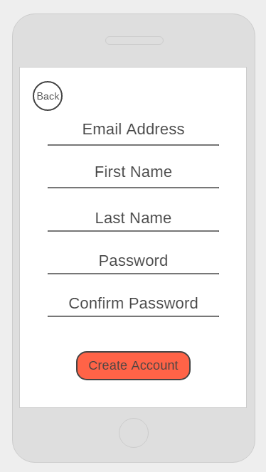

|  |  |
| --- | --- |
| STUDENT NAME: | **Ravjeet** |
| STUDENT NAME: | **Chris** |

|  |  |  |  |
| --- | --- | --- | --- |
| Comments | Date | Done | Group member |
| After creating an account, the user should be able to verify his/her email address | 22 November | ☐ | Abdullahi |
|  | [Date] | ☐ |  |
|  | [Date] | ☐ |  |
|  | [Date] | ☐ |  |

Task 2 - My Trips Screen

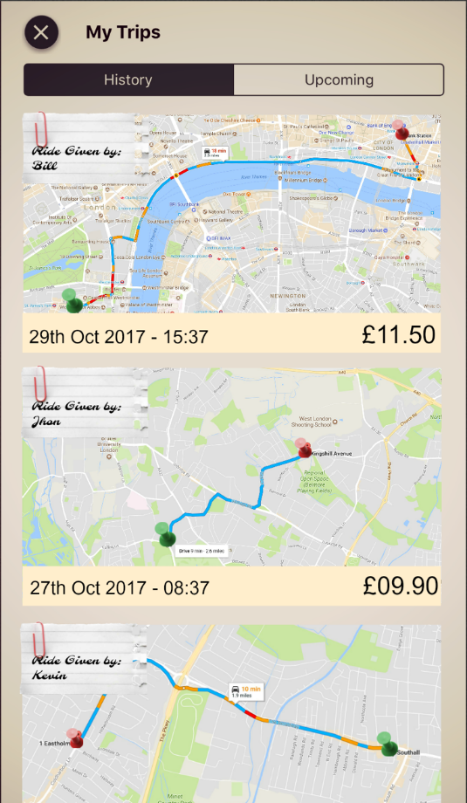

The session screen of the app that will track location of people to set up the journey on google maps and will show meeting points setup by the group and destination point. The Driver will set up where riders can meet up if they live close or riders that live farther away can ping their location as a pick-up point. The screen will have the map displaying all user’s location and will show the best route for the driver to take.

* The red point on the map signifies the pickup location.
* The green point on the map signifies the drop off location(destination).
* The screen shows journey history and any upcoming trips that the rider may have.
* Date and time of the trips are also recorded.
* After every trip, the rider will see the total cost of the trip as well as the name of the driver for that trip.

|  |  |
| --- | --- |
| STUDENT NAME: | **Don** |
| STUDENT NAME: | **Abdullahi** |

|  |  |  |  |
| --- | --- | --- | --- |
| Comments | Date | Done | Group member |
| When we develop this screen, we need to make sure it will be in the journeys tab within the main screen | November 22 | ☐ | Ravjeet |
|  | [Date] | ☐ |  |
|  | [Date] | ☐ |  |
|  | [Date] | ☐ |  |

Trip Overview Screen

This is the Trip Overview Screen which gives more details of a trip when the user clicks on a trip from the History Screen. The screen lets the user view many details about the trip such as who was the driver for a trip who was the passengers who shared that ride and start location and destination. The screen also shows the amount of money owed by the user to the driver.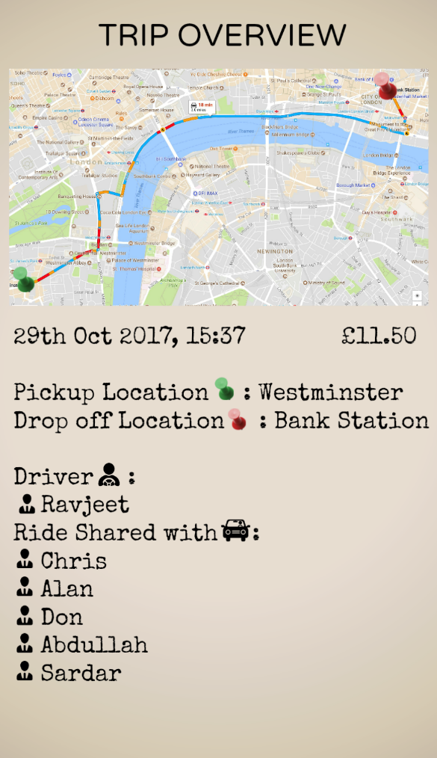

|  |  |
| --- | --- |
| STUDENT NAME: | **Don** |
| STUDENT NAME: | **Abdullahi** |

|  |  |  |  |
| --- | --- | --- | --- |
| Comments | Date | Done | Group member |
| Screen colour scheme and layout will need to match others and should provide journey time. identify which user this is. | November 22 | ☐ | Ravjeet |
|  | [Date] | ☐ |  |
|  | [Date] | ☐ |  |
|  | [Date] | ☐ |  |

Task 3 - Session Screen

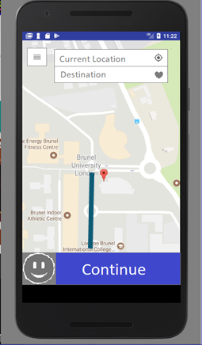

The session screen of the app that will track location of people to set up the journey on google maps and will show meeting points setup by the group and destination point. The Driver will set up where riders can meet up if they live close or riders that live farther away can ping their location as a pick-up point. The screen will have the map displaying all user’s location and will show the best route for the driver to take.

* Menu button if the user wants to return to a specific screen.
* Smiley face (placeholder) used to enter the number of passengers to split the fare accordingly.
* Within this blue box we will put information that the user would like to know for their journey for example we can add the total distance, the amount of time it will take and the cost of the fuel consumption.
* When the user enters a starting point and a destination point a polyline will be shown for the user to search and examine their journey.
* The marker will pin point the user to their current location by enabling GPS permissions.

|  |  |
| --- | --- |
| STUDENT NAME: | **Alan** |
| STUDENT NAME: | **Sardar** |

|  |  |  |  |
| --- | --- | --- | --- |
| Comments | Date | Done | Group member |
| This will be an important screen that sets the journey route and who is going on this journey. It should use Google maps API. | November 22 | ☐ | Ravjeet |
| “Current Location” should be “Pickup Location” with the option to set it as your current location. The passenger will likely not organise pickup for their current location because they will plan the journey ahead of time. | November 22 | ☐ | Chris |
|  | [Date] | ☐ |  |
|  | [Date] | ☐ |  |